Spring Boot Assignment

Requirement 1:

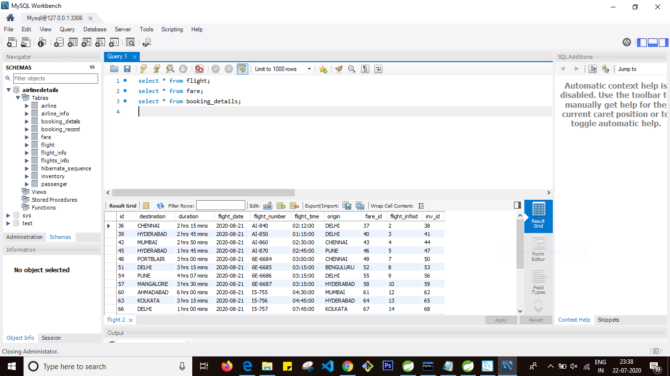

Requirement 2:

1.Write a class to retrieve all Indigo flight trips of August month, and on August 21st2020

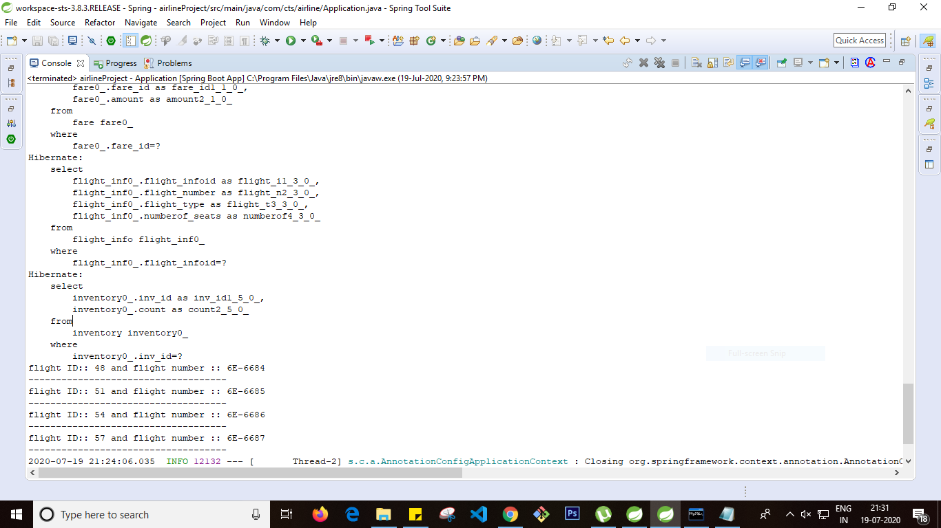

2.Write a class to find all the flights leaving from Delhi airport on 21stof August 2020

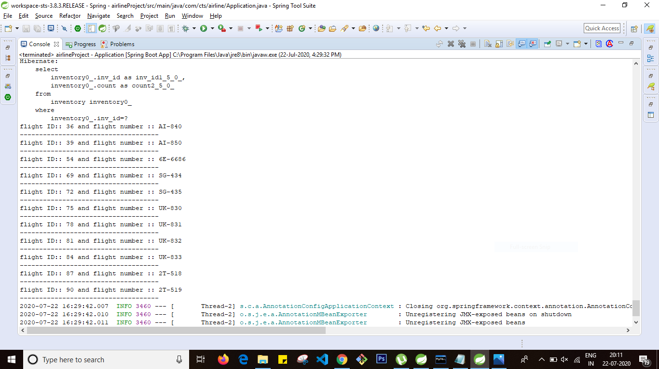

3. Write a class to search for flights flying between DelhI to Chennai on 21stAugust2020 by flight fare low to high

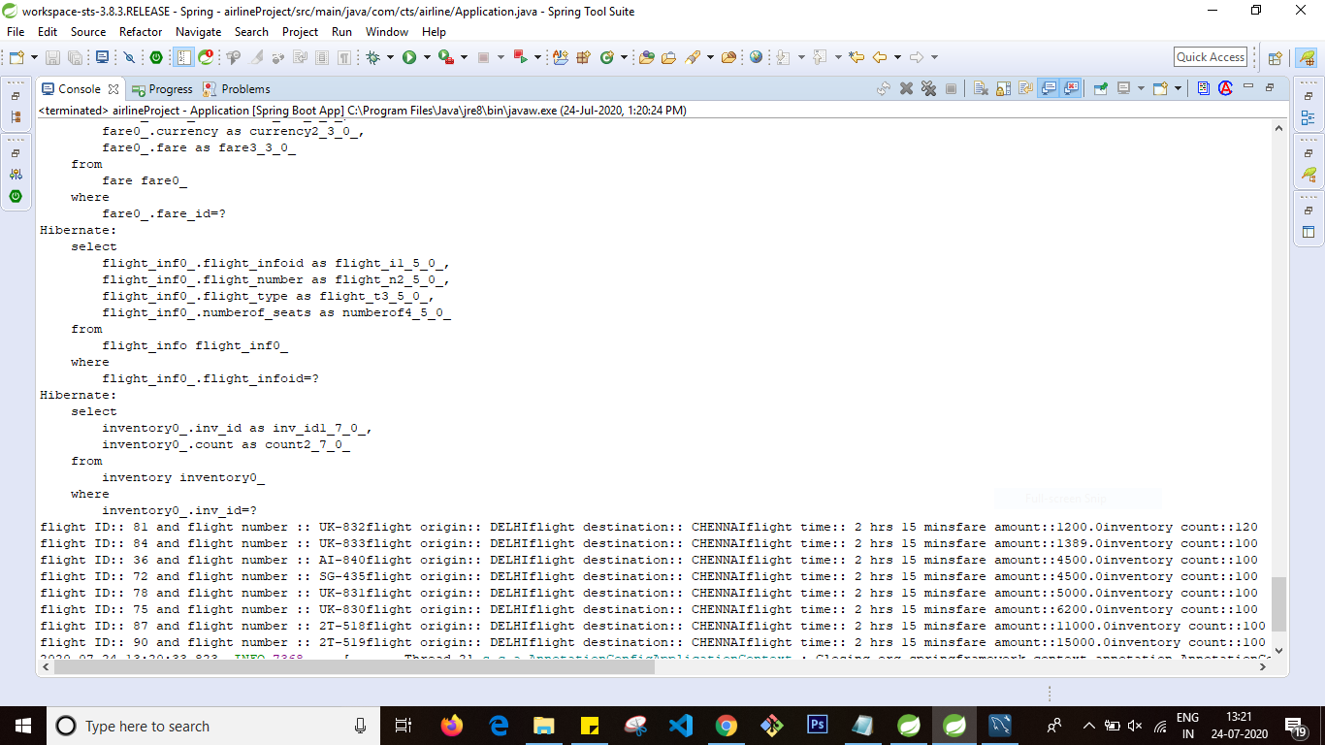



4. Write a class to search for flights with combination of flightnumber and origin and destination

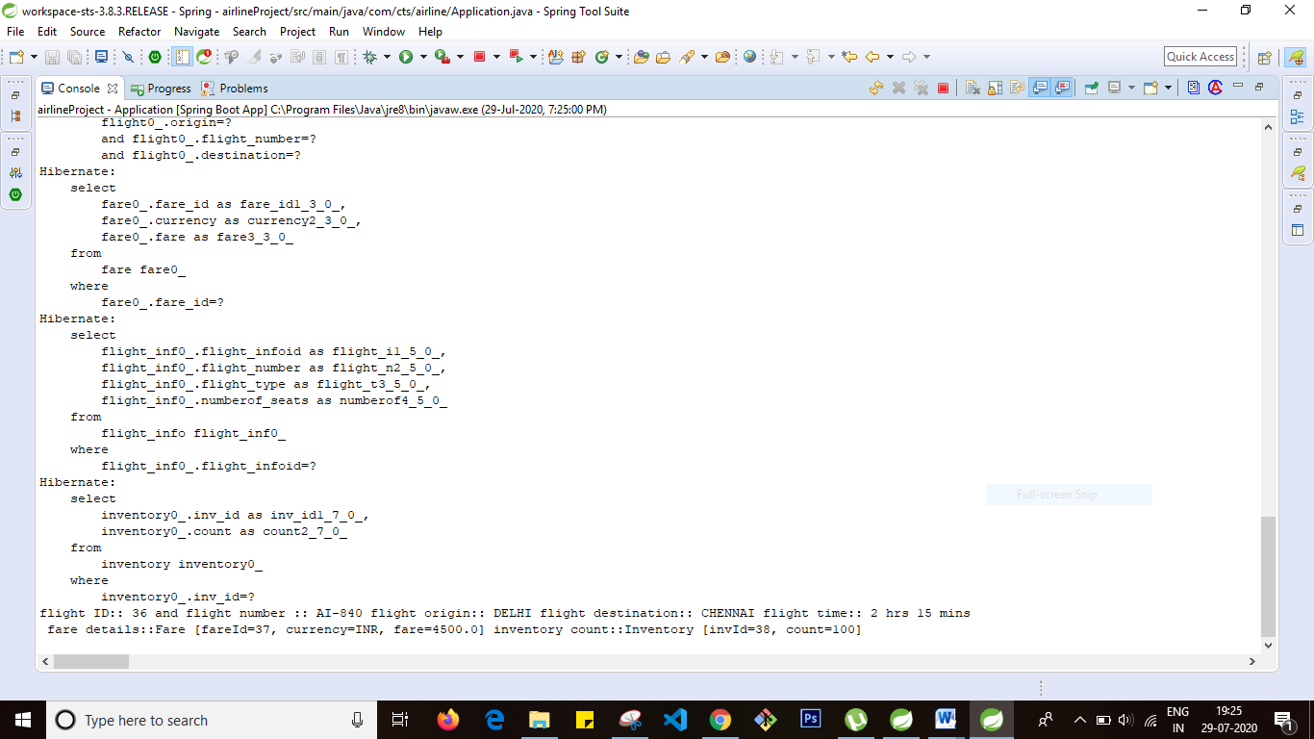

5. Write a class to search for a single flight with combination of flightnumber and flightdate and flighttime.(make sure only single flight is displaying for this criteria)

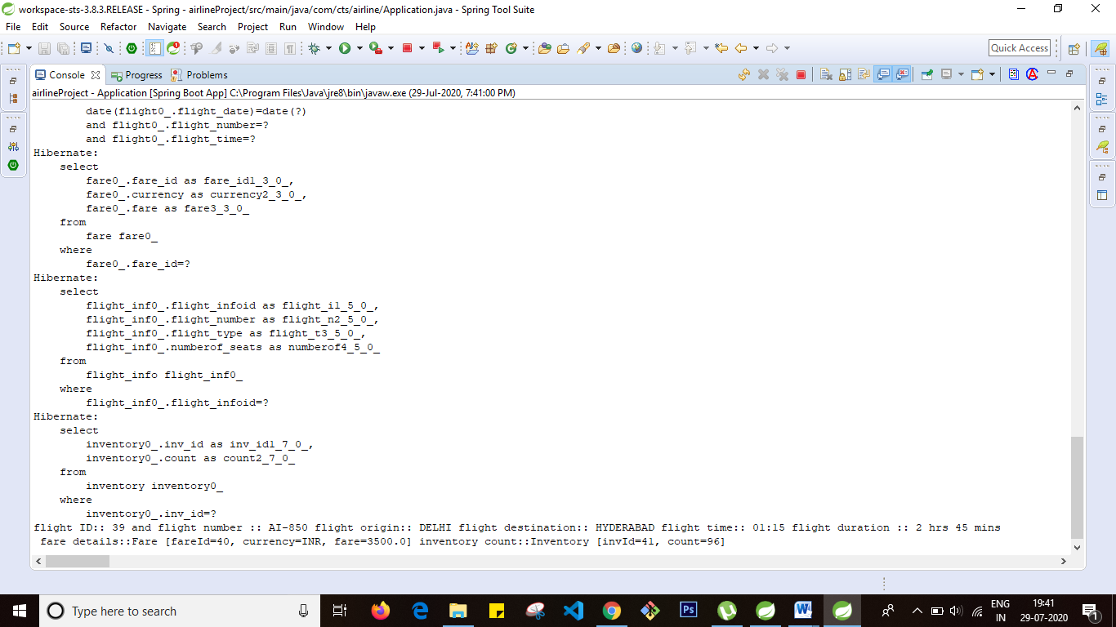

6.

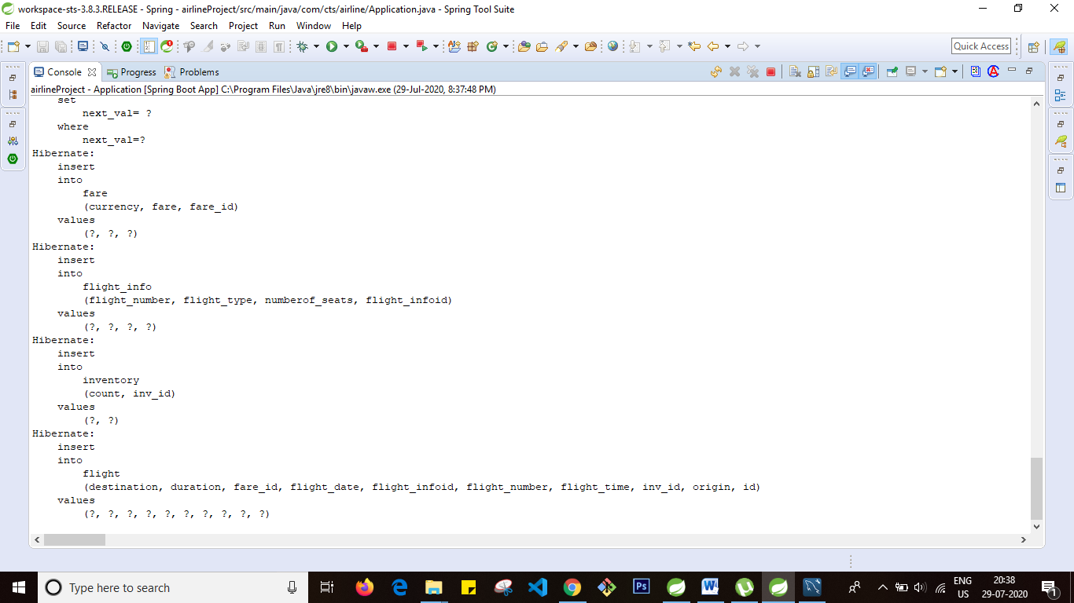

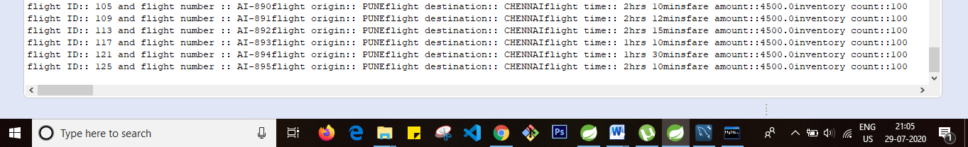

7

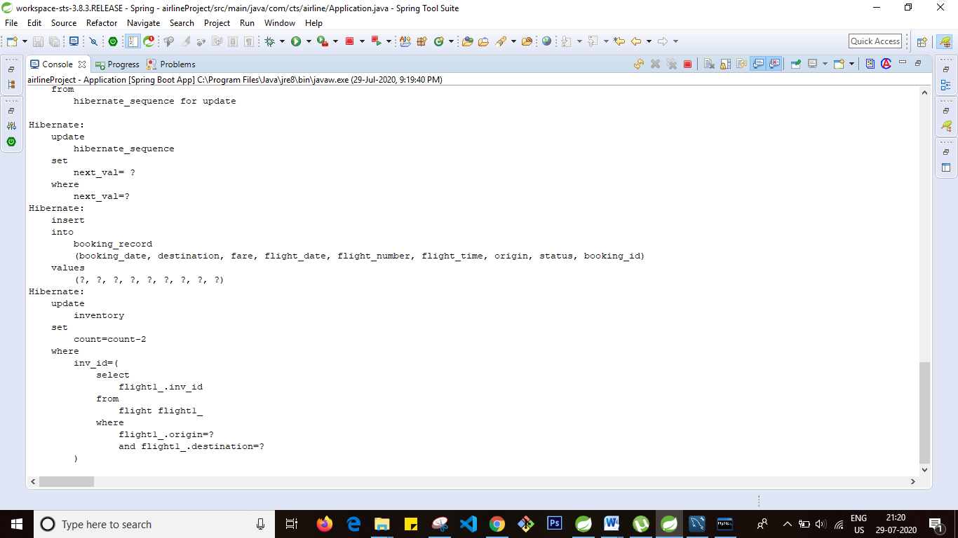

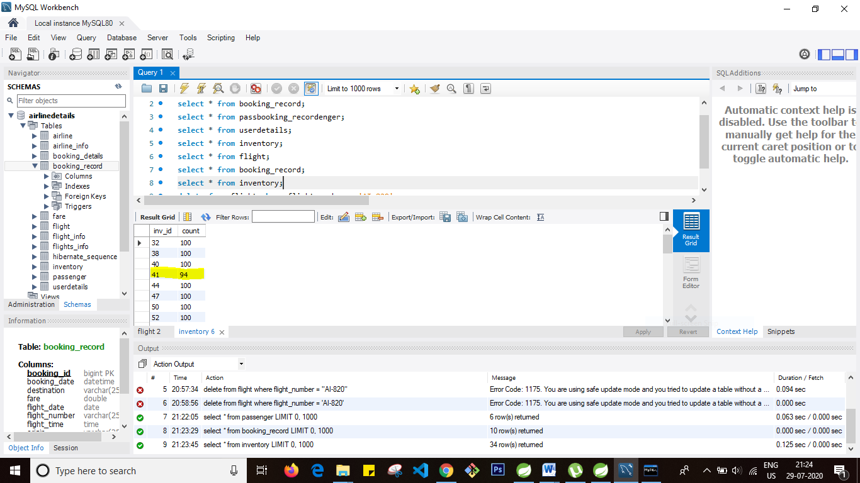

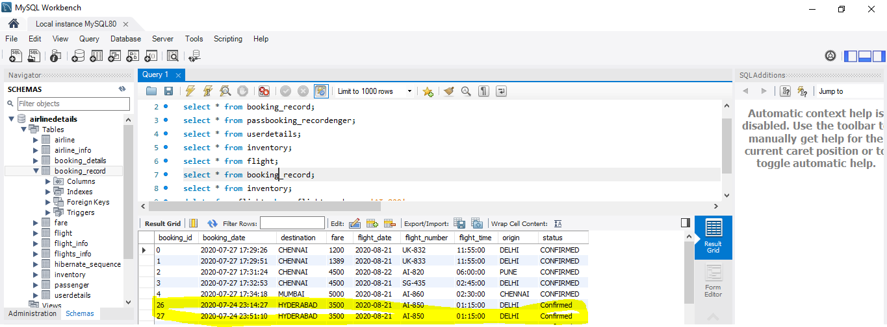

Requirement 3

1.Create a login form to allow the passenger to login to portal.

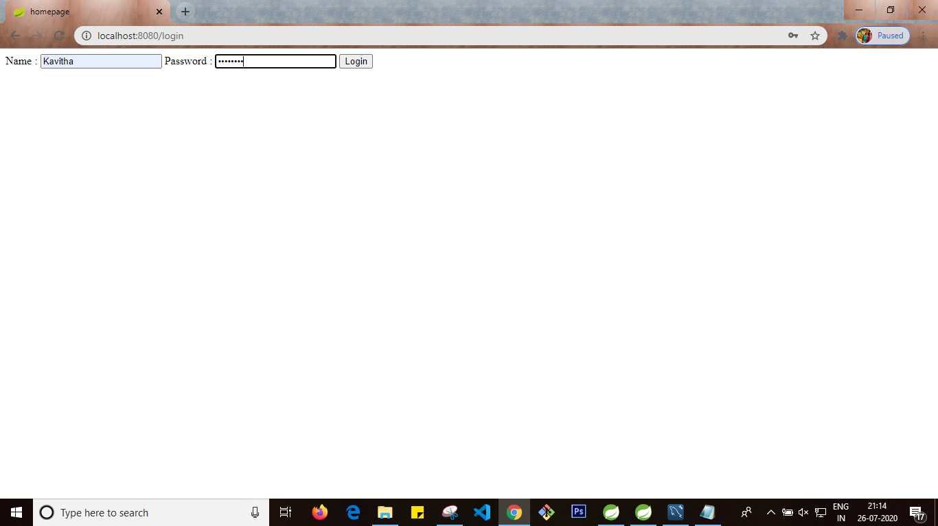

Successful login page

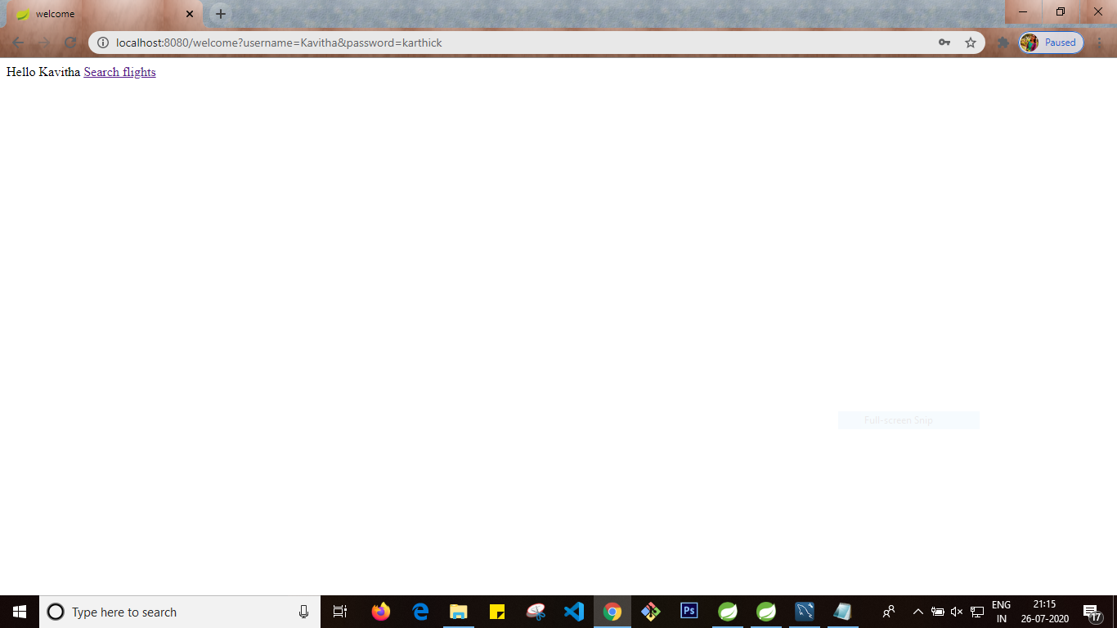

Failed login

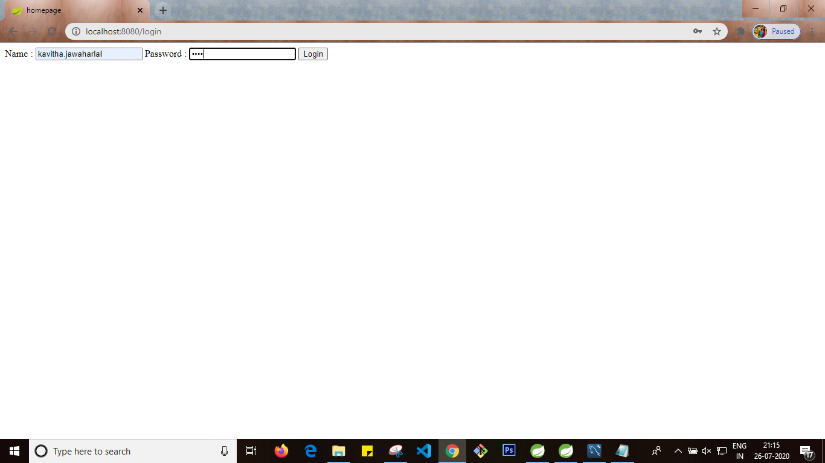

Login page validation

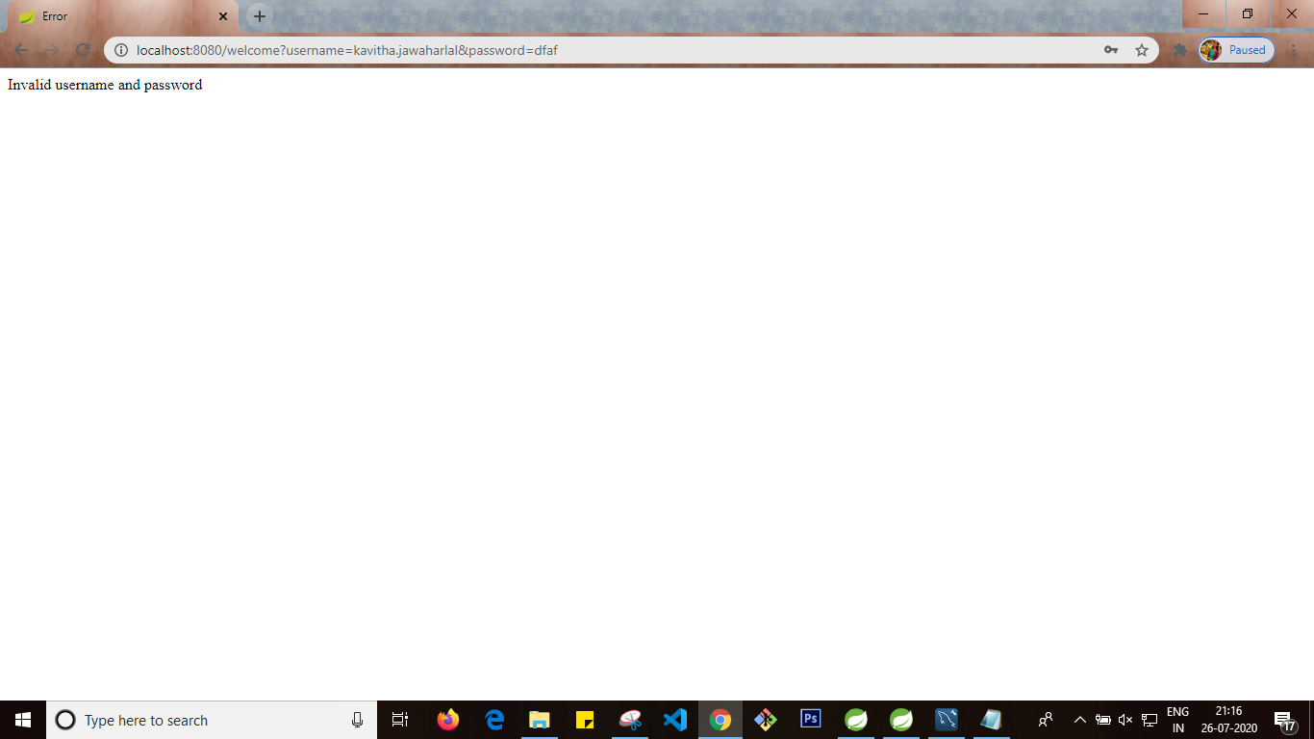

1.Allow the passenger to register himself in case if passenger is not registered -🡪 user with name Praveen is registered

Created a registeration form with fields name,password mailaddress phone number and gender

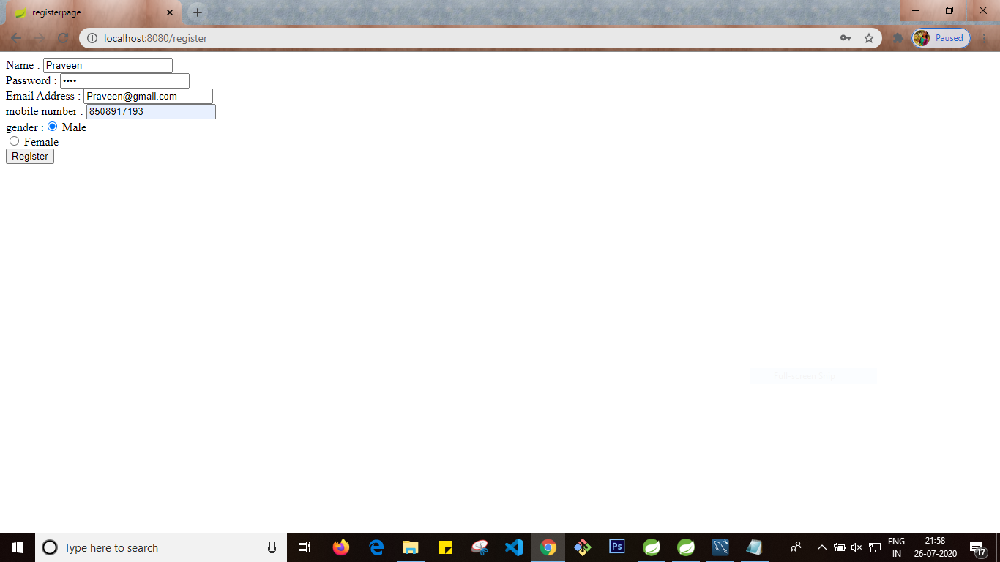

Registered login will be stored in userdetails table

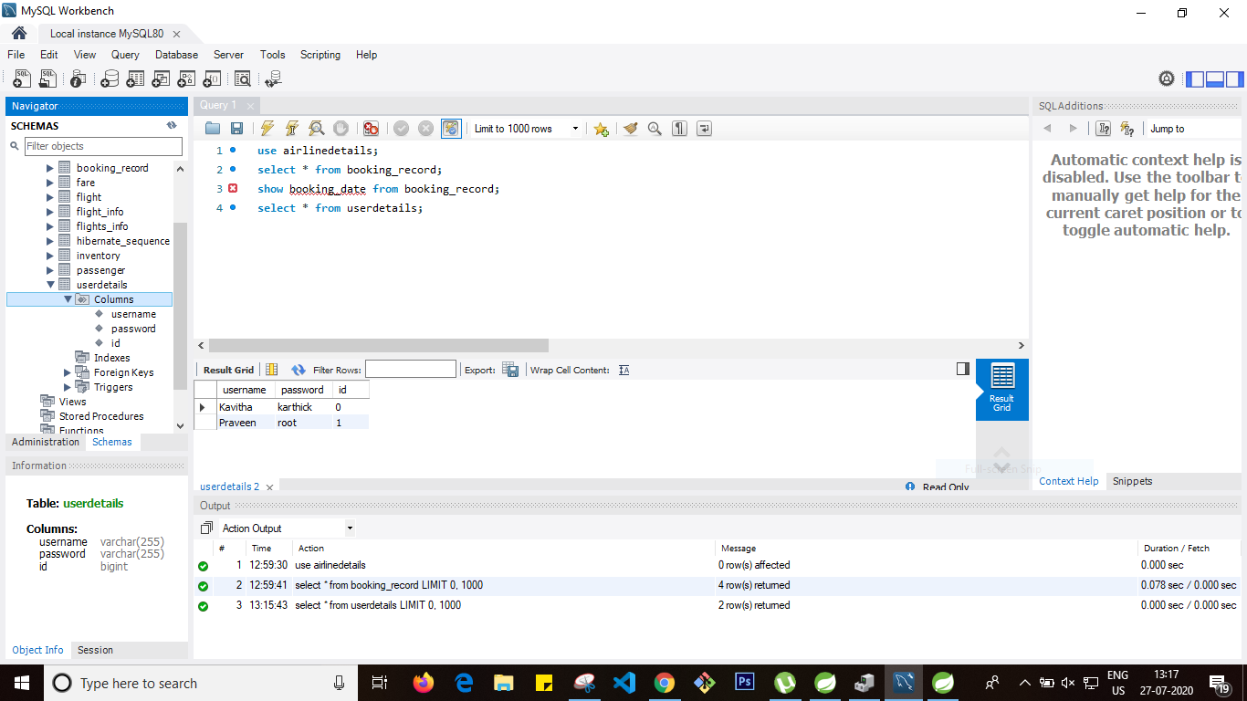

Logging in after registeration

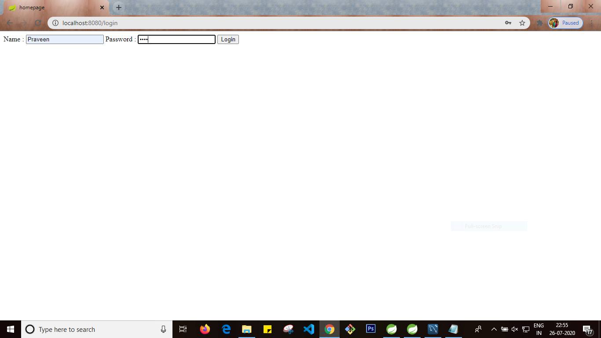

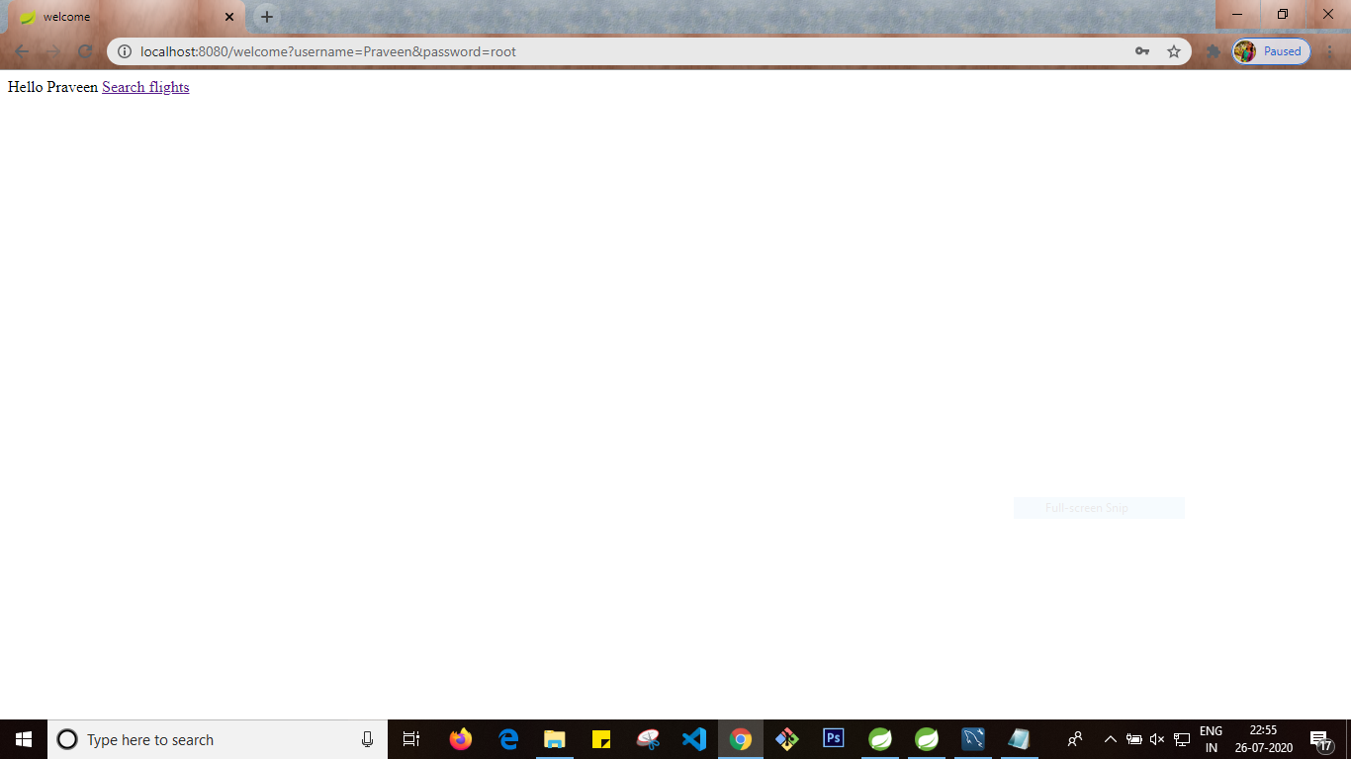

2.Create a flight search form to search for flights with origin destination flight date (without time) and submit button with search label

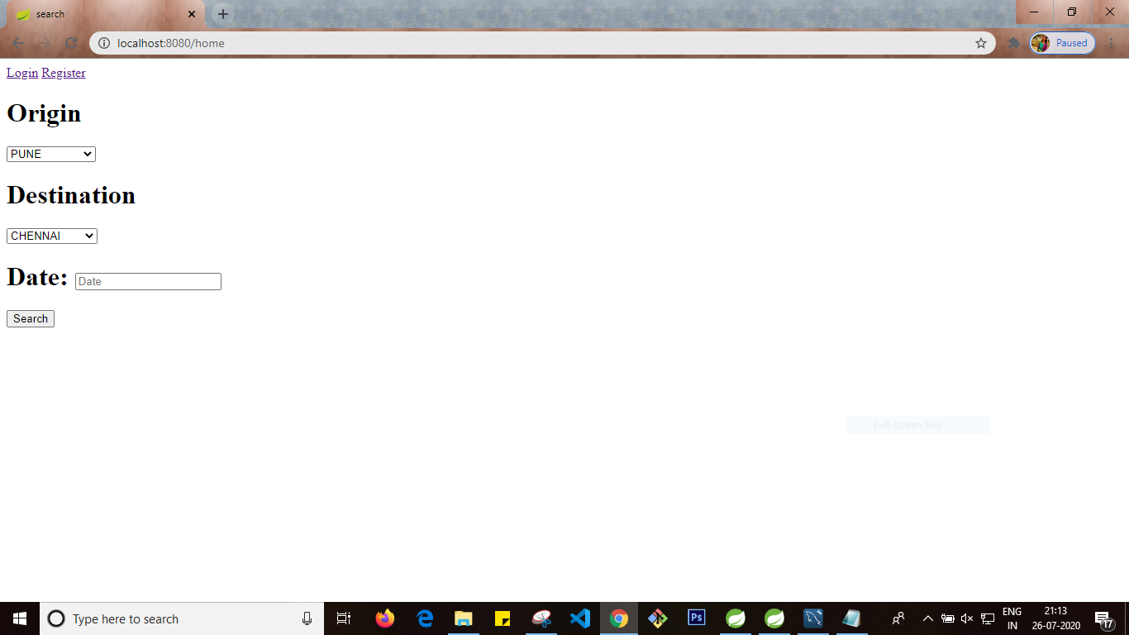

Origin drop down displays all the distinct values from origin column in flight table

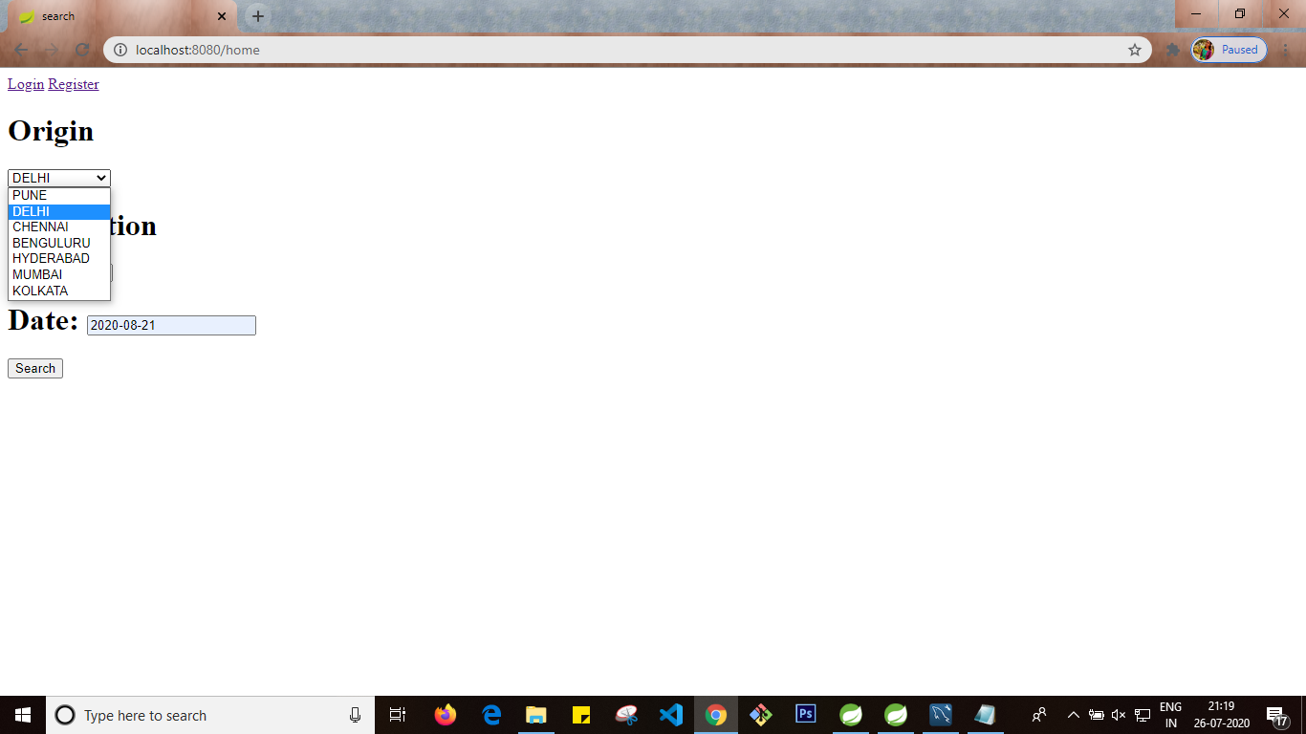

Destination dropdown lists all the values from destination column in flight table

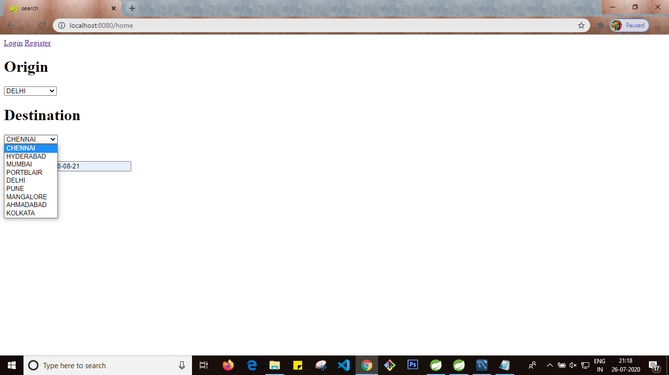

Date will be selected in date picker

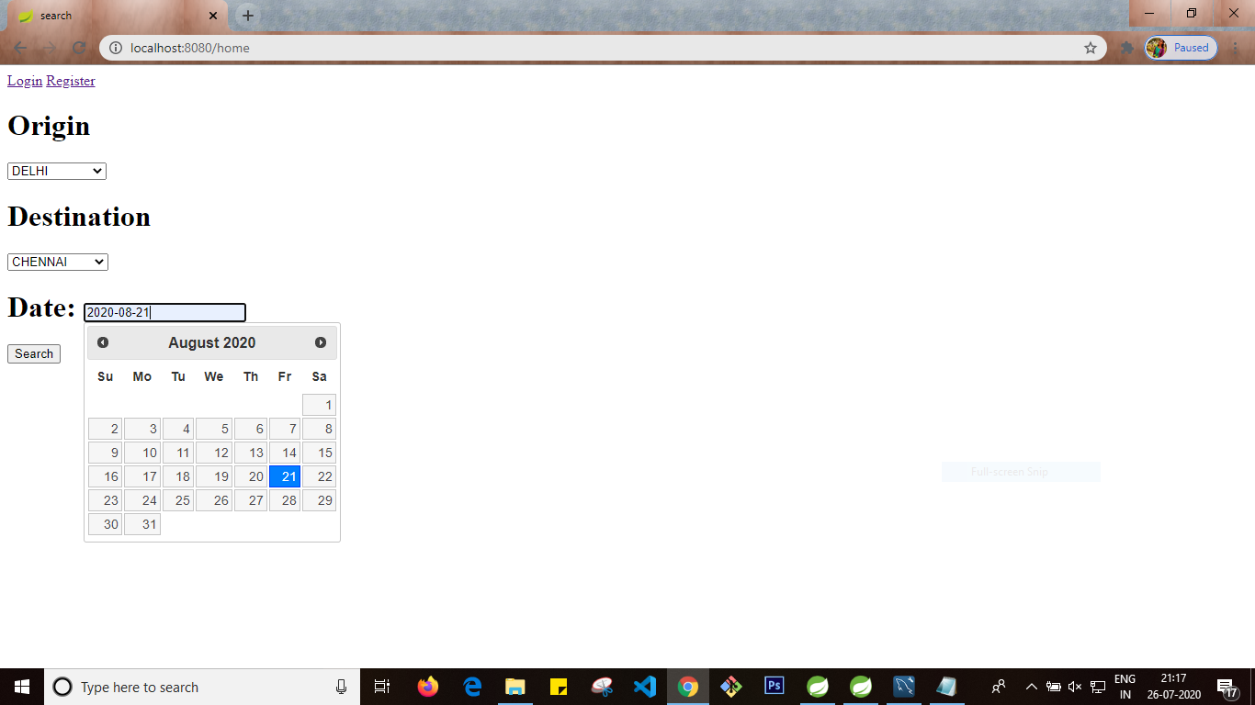

3. once passenger click search button display all scheduled flights in table format and generate book button for each listed in table format

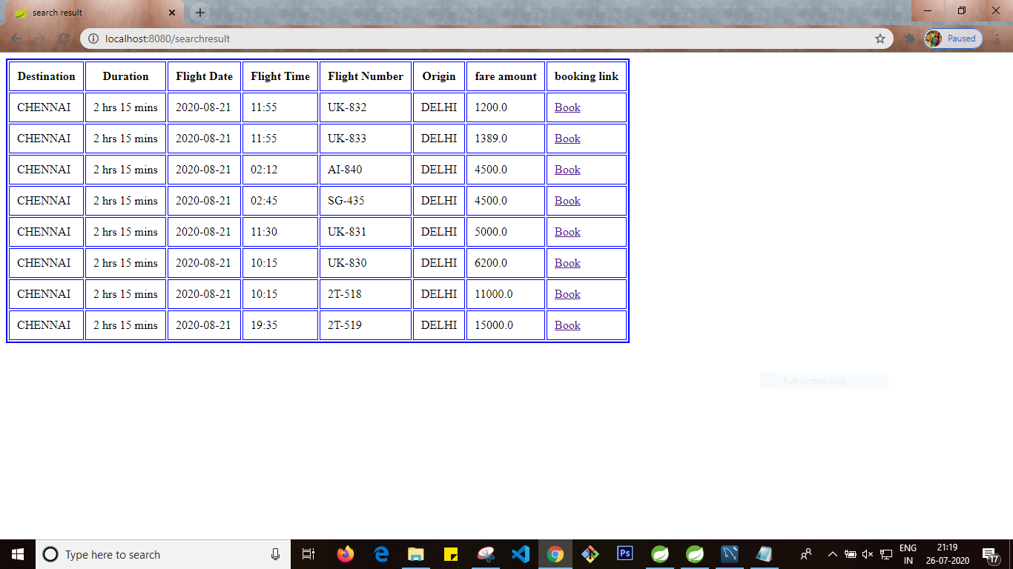

1 a. any passenger can search for flight but registered passenger can make booking

Booking will not be done if user is not registered

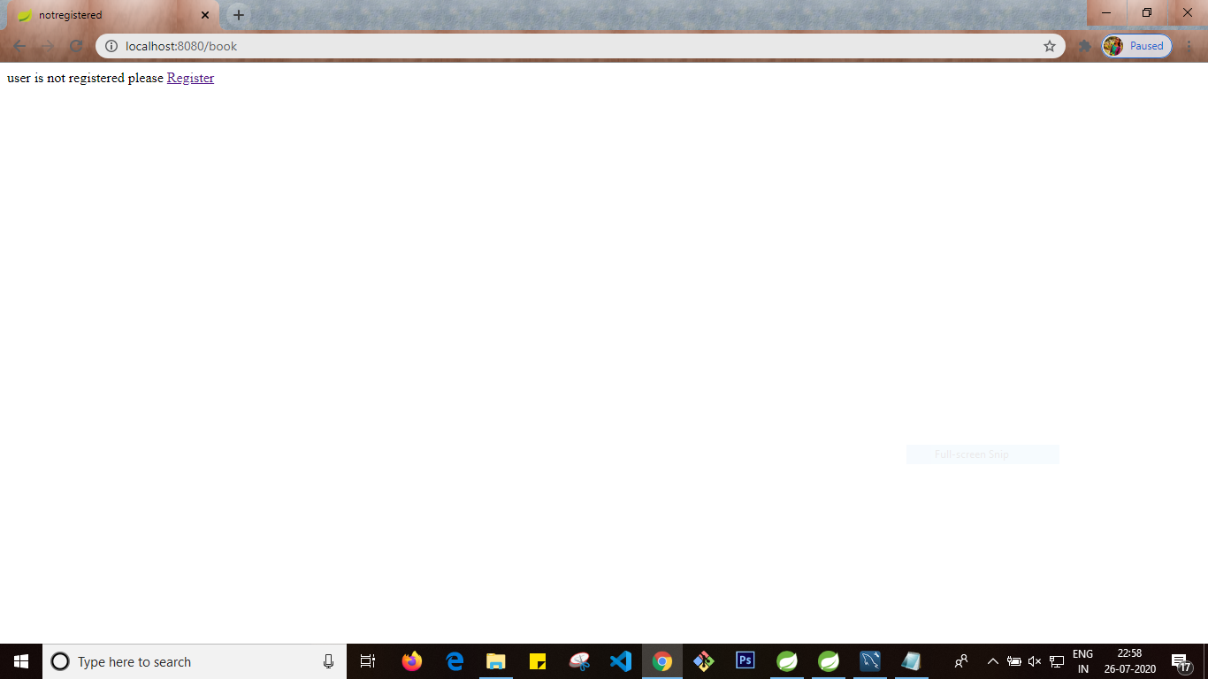

Requirement 4

1.Once passenger click book button from above table display passenger form to accept first name, lastname , gender, mobile number

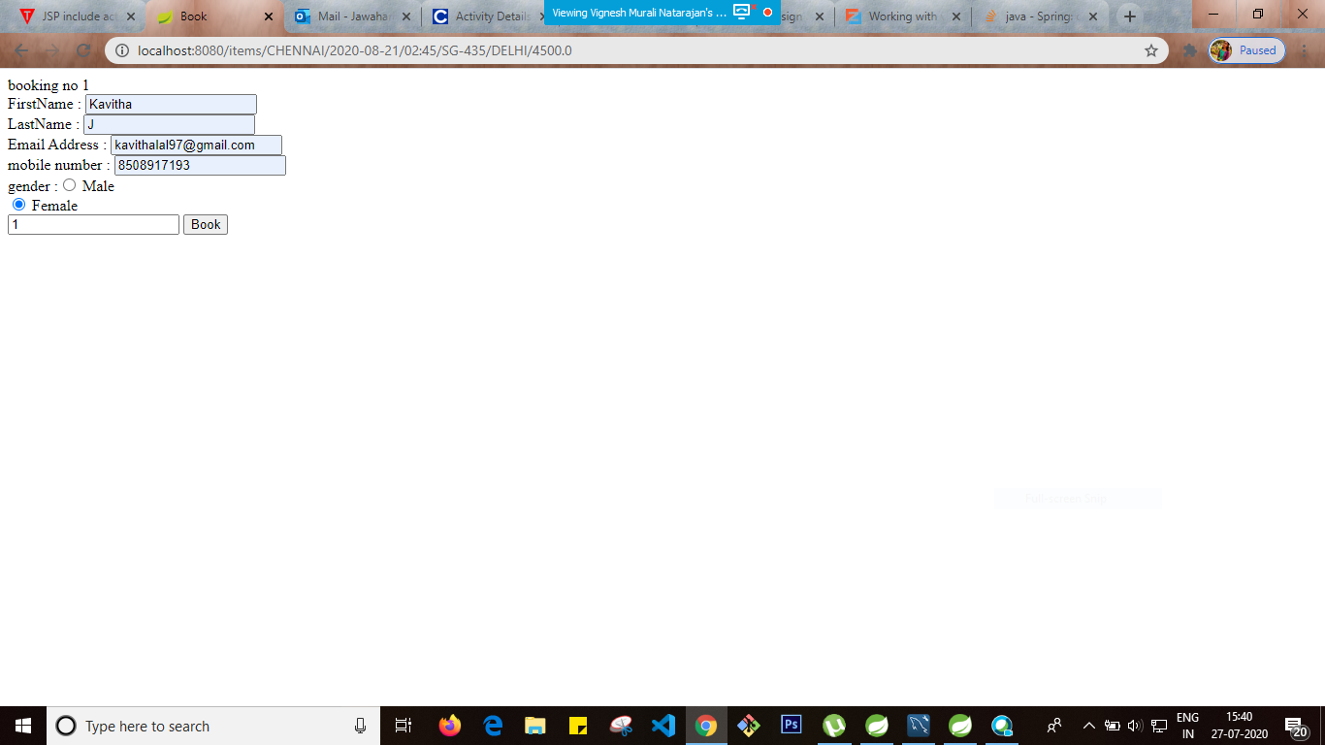

Booking no 2

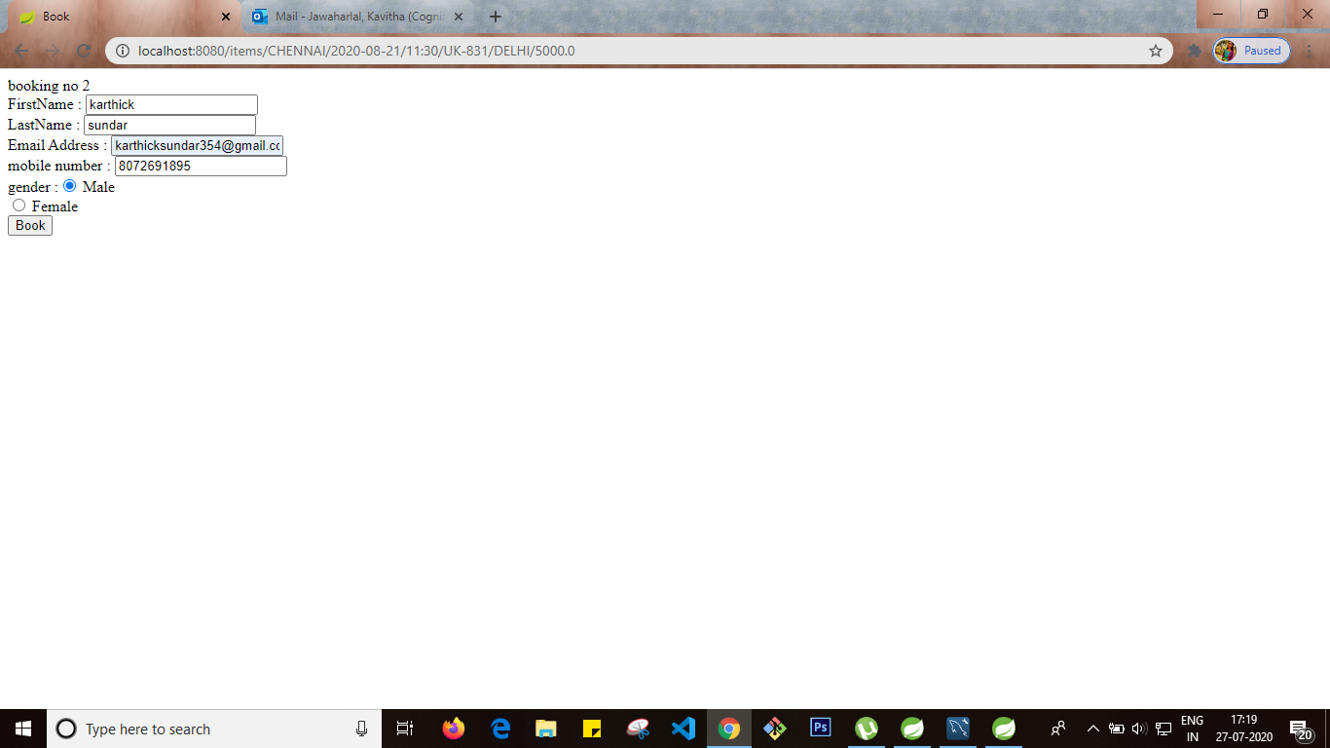

Booking no 3

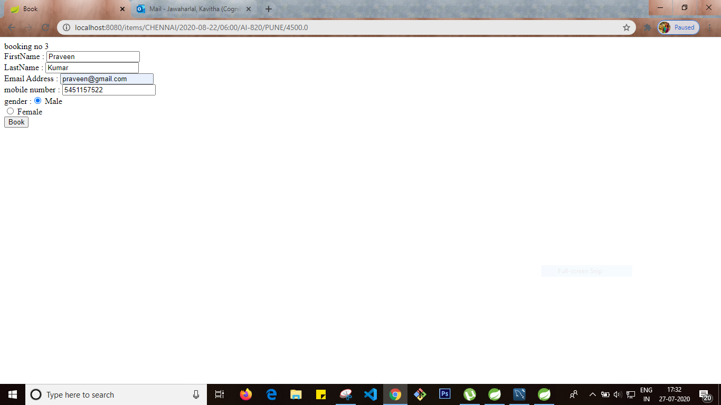

Booking no 4

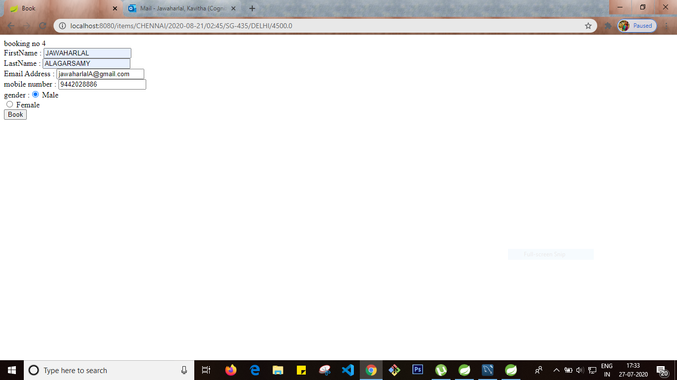

Not more than 4 tickets can be booked

Booking no 5 will be cancelled.

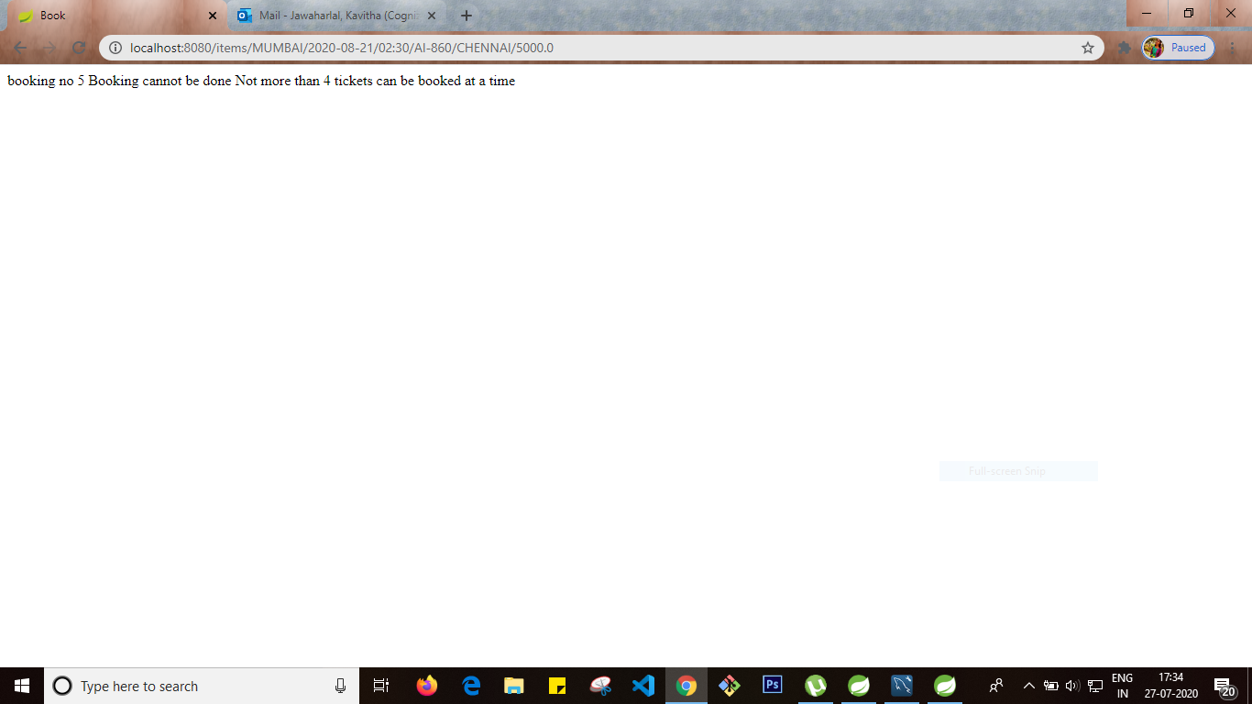

2.Booking record table updated with booking details

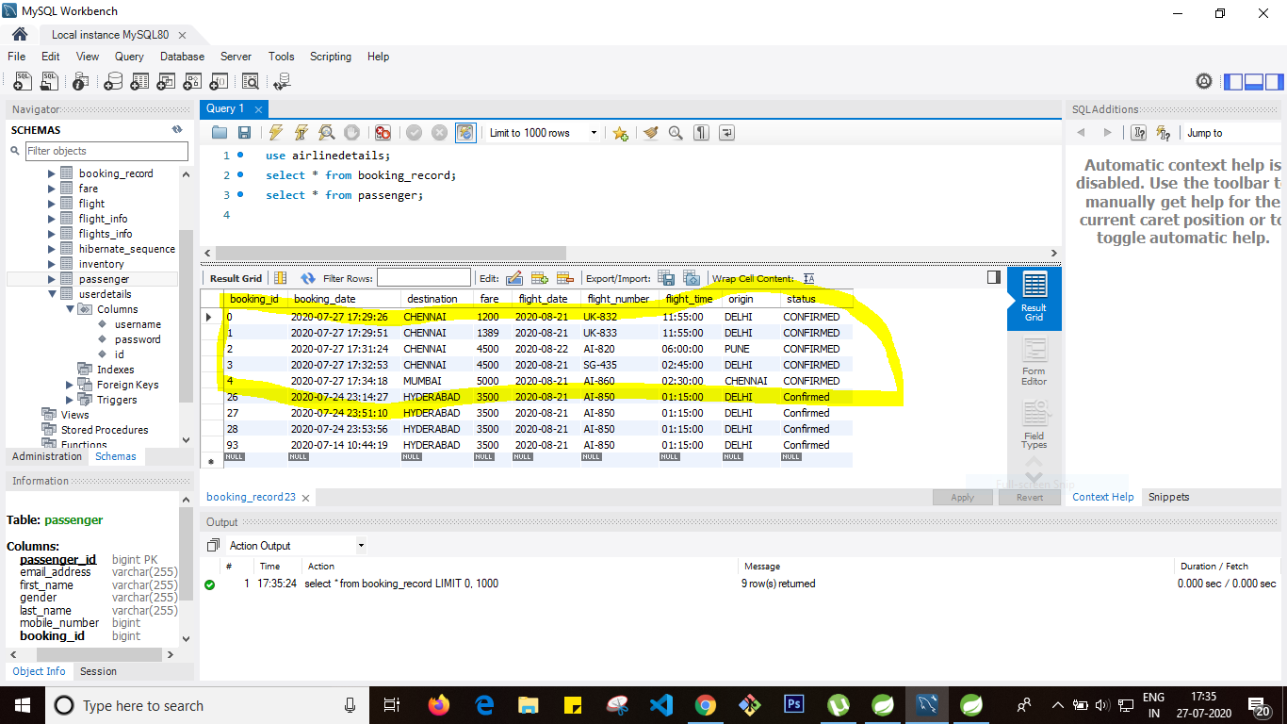

Passenger table updated with passenger details and booking id

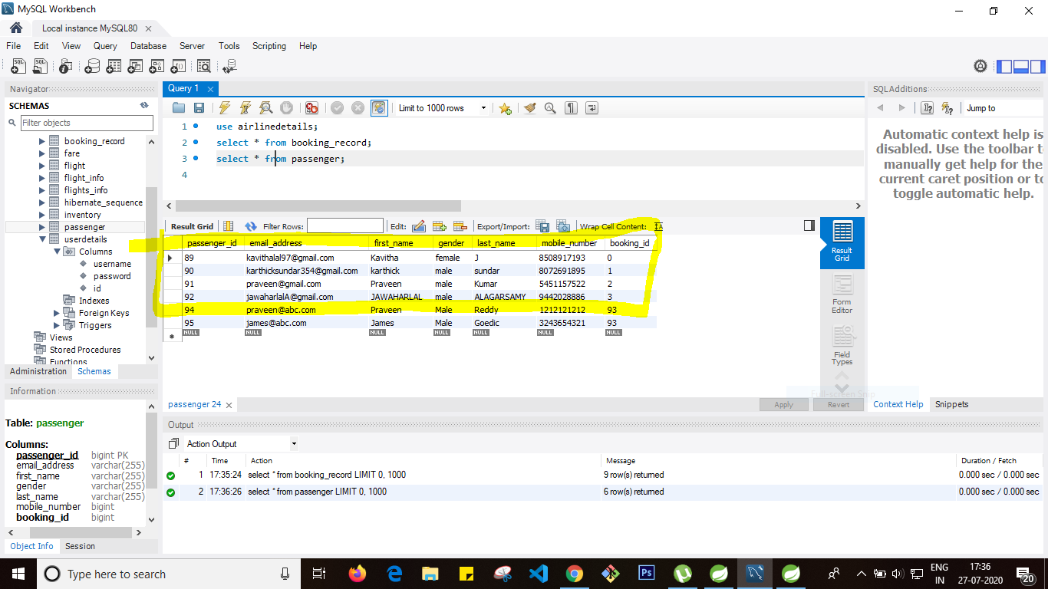

3.Check in link in home page to view check in details based on booking id and assigned seat details

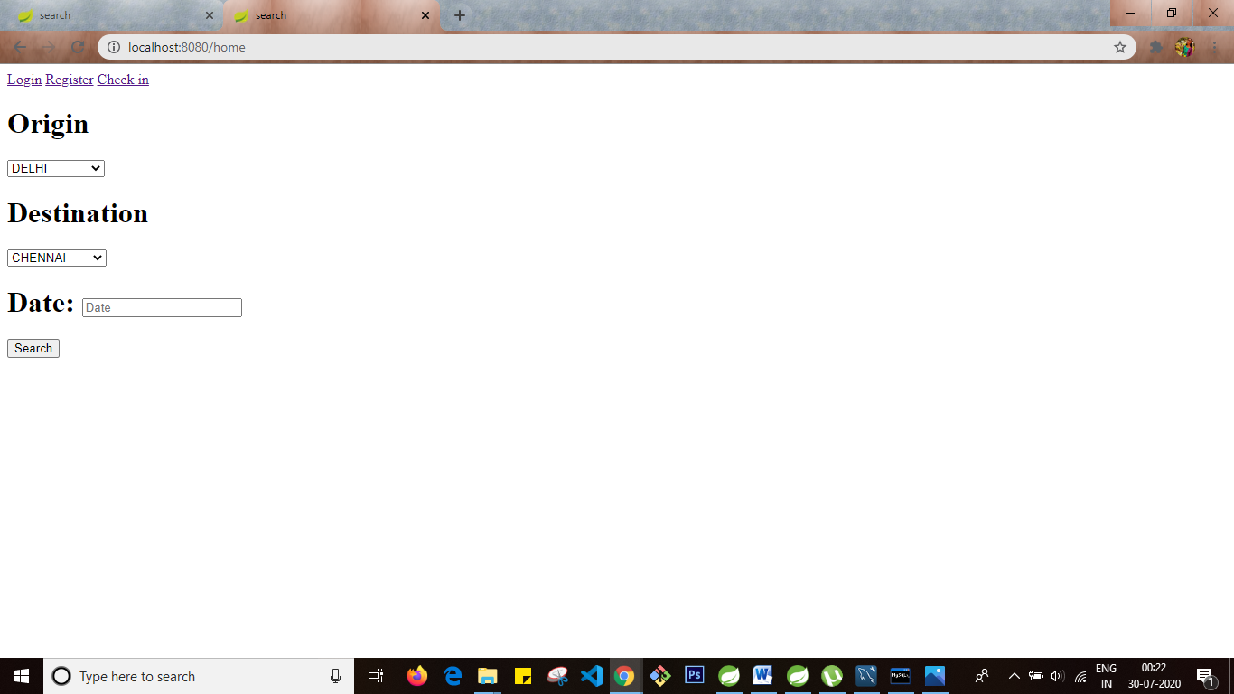

Check in page to select booking id and seat number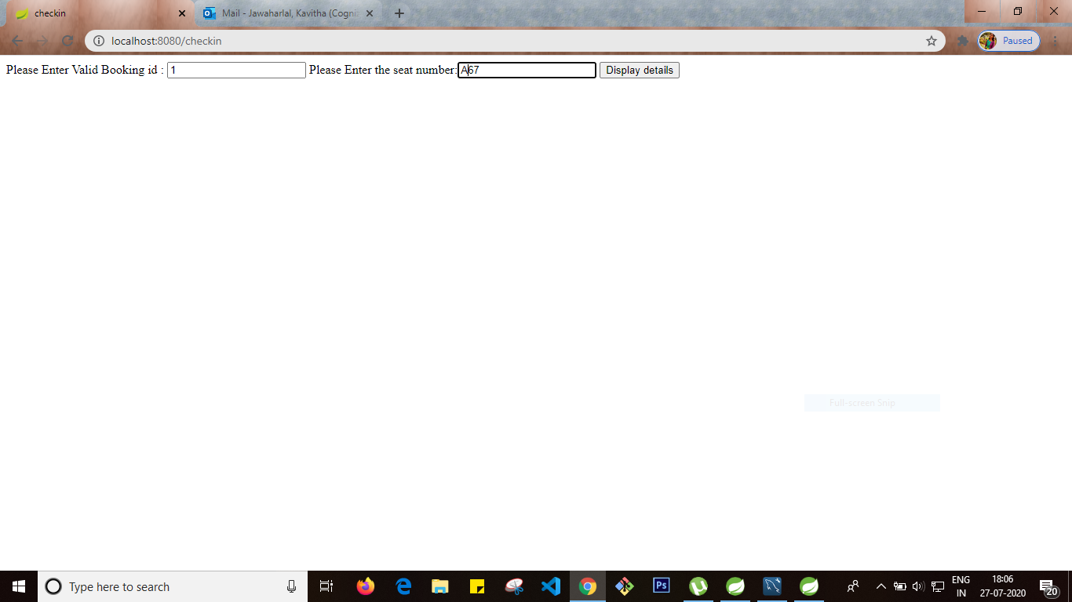

Checkin details for booking id 1

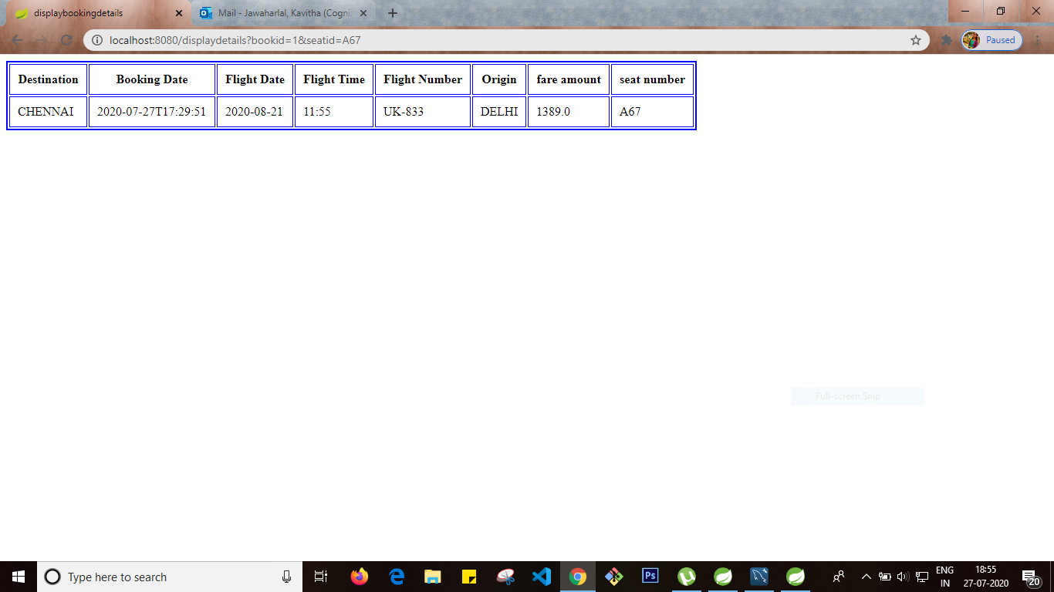

Requirement 5

Getmapping – to get all the flights in the flight table

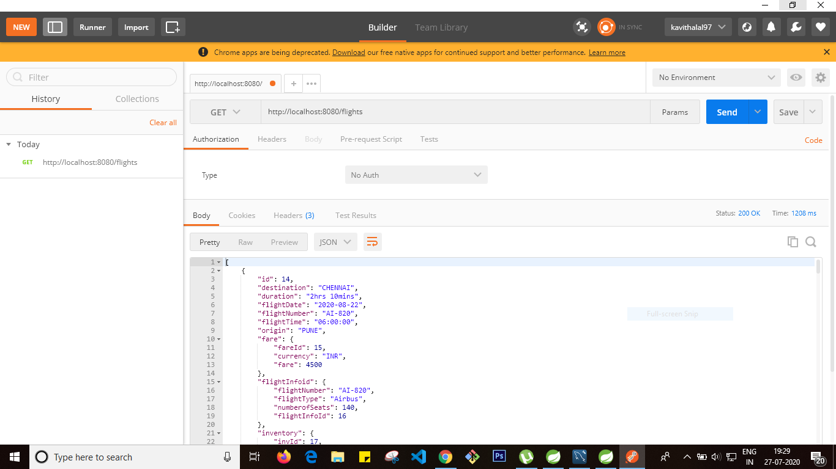

Postmapping – inserted new row for userdetails

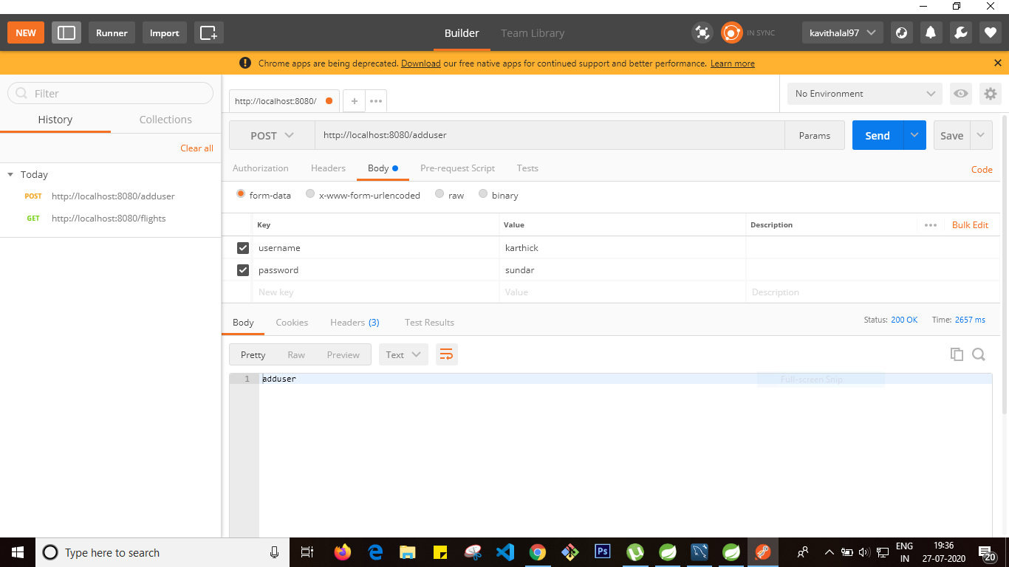

Userdetails table after post

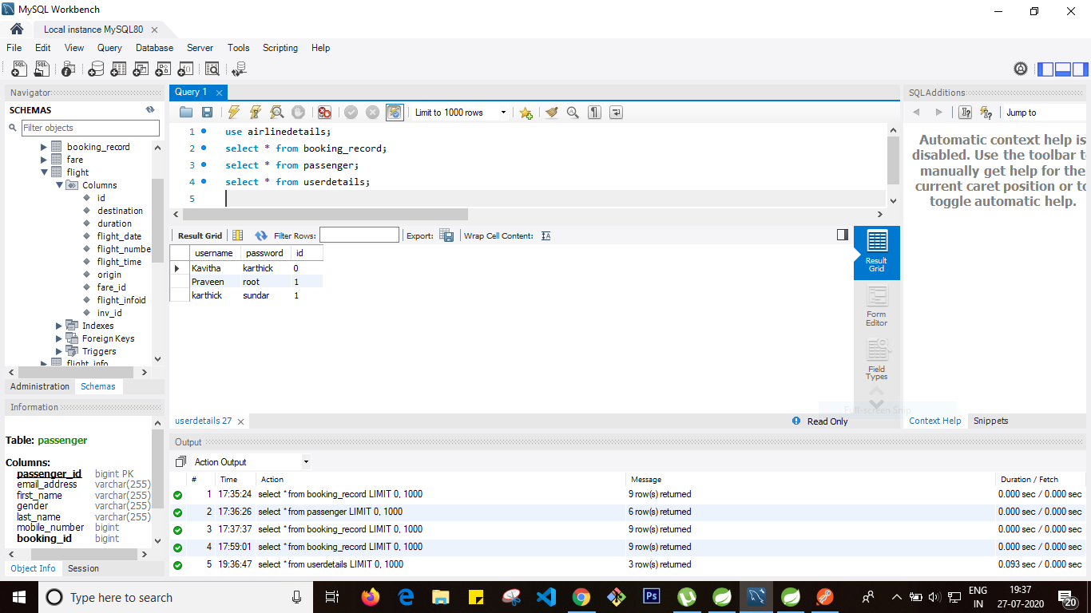

DeleteMapping – deleted flight with id 14

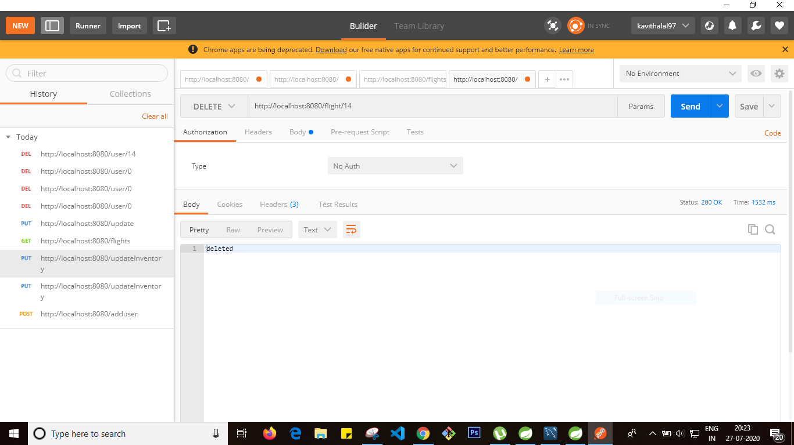

After delete , flight table result

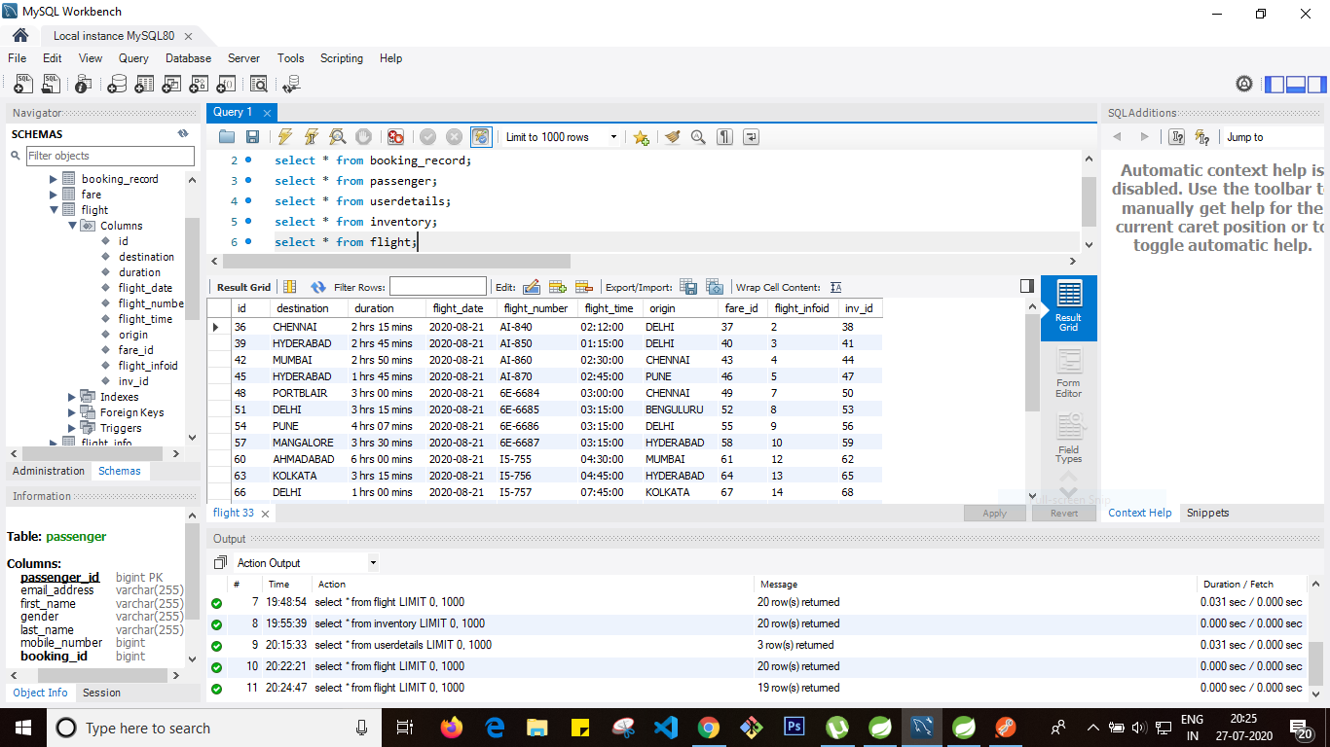

Code for mapping

